Theme
How accelerating success across industries will benefit us all

Related Topics
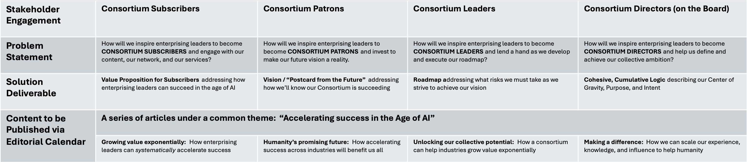

Outline

Draft

